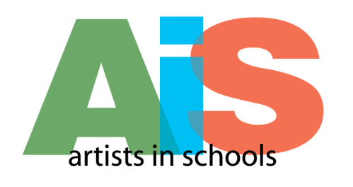
FINAL REPORT AIS 14-15 INSTRUCTION PAGE

- NEA Grants Activity Survey ( http://www.cac.ca.gov/programs/forms.php)
- A 10% Invoice Form; and (http://www.cac.ca.gov/programs/forms.php)
- A Final Report. Within the context of your ongoing artistic and educational programs, please answer the following questions (up to 3 page maximum):

Utilizing the evaluation plan you developed for your application, select one of your Visual and Performing Arts Standards to discuss. See example below :

Grade Level: Intermediate |  |  |  | Discipline: Music
Visual and Performing Arts Standard:

Creative Expression: Students play and interpret a song.

What is the activity? |  | Desired Outcome? | How will you measure?
The teacher will preview interpretation of a song by playing the song and make a homework assignment. |  | Students invest sufficient practice time to be able to play the song with proper interpretation. | The student Grading Sheet contains a list of benchmarks for student performance (steady beat, clarity of sound, etc.) The student’s practice log (signed by the parents) reflects the amount of time spent in mastering the skills necessary to achieve the desired outcome.

2014-2015 Narrative Report

Organization:
Contact:
Application No:
Email Address:
Phone:

Grade Level: |  | Discipline:
Visual and Performing Arts Standard:
What is the activity? | Desired Outcome? |  | How will you measure?

Please respond to each question separately using the appropriate number.
The purpose of this evaluation is a candid review of your residency activities. The CAC is not only interested in the positive results of your program, but also what changes (if any) would make your programming more effective.

In a narrative (no more than three pages long) address the following questions:

1. Describe how CAC funding supported your organization’s ability to partner with this school.
- Discuss why you selected the above Visual and Performing Arts Standard to focus on?
- Discuss the activity from both the student’s and the teaching artist’s perspective. (Did the activity work? Why, why not?)
- Discuss the measurement tool(s) you utilized to evaluate your outcome.
- How did this activity contribute to the student’s sequential advancement in the arts?
- What do you think were the most important accomplishments or lessons learned by measuring this activity? Any unexpected results?

Do not submit the final report instructions pages

Please print out your report and submit to the CAC no later than 30 days following the end of your grant agreement. Mail to the attention of:

Wayne D. Cook
California Arts Council
1300 I Street, Suite 930
Sacramento, CA 95814

